In visiting Chinook’s Edge School Division, Alberta during our LEAP exchange this year we were treated like honoured guests and had the privilege of meeting and sharing with an amazing group of educators who opened their schools, classrooms, meetings and homes to us, ultimately providing professional learning which was influential, current and timely. While my research question was neither really addressed nor answered I came away with so much more that I have been able to implement since returning. My question was based on Visible Learning – letting students into the ‘secret business’ of what they are learning and why. The new school year was only 20 days old and teachers appeared to be getting to know their students. Perhaps this was a reason why answers to my question were not ‘visible’; perhaps I didn’t ask the right people the right questions to elicit an answer or perhaps setting up their lessons with success criteria, WILF (what I am looking for) and WALT (we are learning today) statements were just not part of their T/L practice. The following are photos (annotated) taken in a variety of schools where I could see a link to my research question. I’m a visual learner; hence you get a visual report! Elizabeth Mulligan

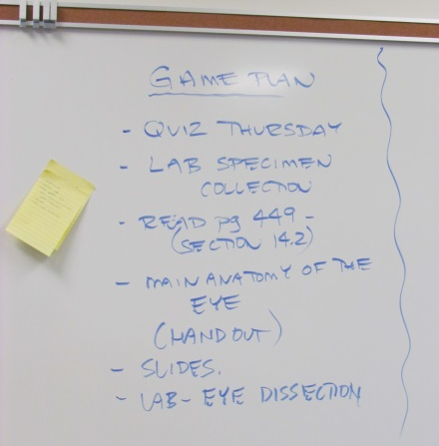 | I told a Vice Principal in Penfold High School what I was interested in researching and he looked completely flummoxed! When we walked past his class later in the morning he took great pains to have his science class tell me what they were learning, the lesson plan and about a test they were going to have.  Spontaneous but not consistently practiced!!
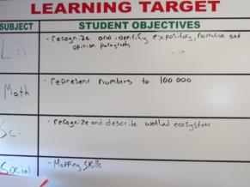 | This whiteboard was in an Elementary classroom (Grade 5) and appeared to be utilised. Unfortunately I didn’t get to talk to the teacher about this. At the least this provided his class with a visual representation of where they were headed.
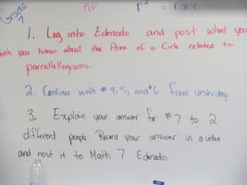 | This Grade 7 maths class at Westglen High School was awesome! Kim is a maths/science teacher who had her class actively engaged, working in groups, asking questions of each other and giving peer and teacher feedback. Kim also ‘fed forward’ to students asking ‘where to next’ and ‘what else could you try’ questions and left them to work on it.  She used technology as an integral part of the lesson, built on prior knowledge of the students as well as previous teaching points. On showing these photos to a principal colleague in my CoS his comment was “that’s a maths lesson? – students don’t stand up or walk around in maths lessons.” I think/hope he was joking.  These students knew exactly what they were doing and where they were going.
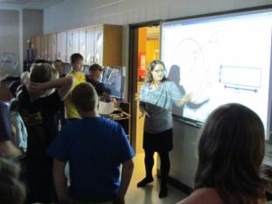 | 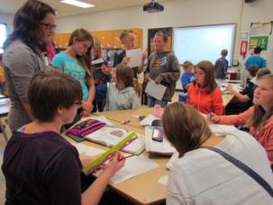
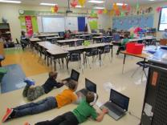  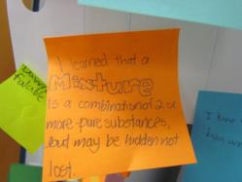  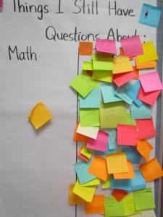 | Kim had many charts around the room where her science and maths students could pose questions and also share their learning. There was a very real sense of connection between the teacher and students; a sense of purpose and rigour.  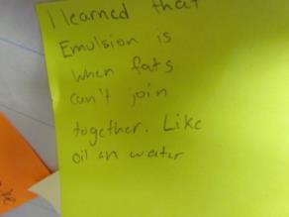  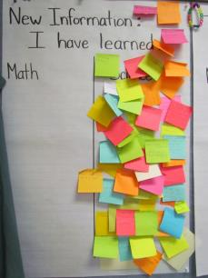  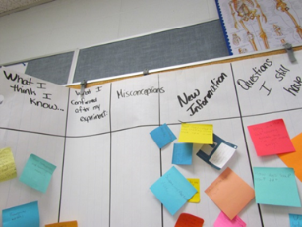  This Grade 2 was involved in ‘Daily Five’, a literacy approach which has become popular in NSW schools over the last couple of years. This class had high engagement levels as their teachers (team of 2) had set the criteria for each of the 5 activities with explicit expectations and outcomes for the lesson. These students gave feedback to each other or received it from the teacher.

